**PROJECT PLAN**

**Shreya M Hegde PES1UG22CS73**

**Shreya Mittal PES1UG22CS575**

**Project Title: Travel Agency Management System (TADMS)**

**Project Lifecycle:**

We will use the **Agile** methodology to accommodate evolving requirements and continuous feedback from customers and the agency. Agile facilitates iterative development and frequent releases, improving customer satisfaction and system quality.

**Tools Used for the Project:**

* **Planning Tools:** Jira for task management and sprint planning.
* **Design Tools:** Figma for designing user flows and mock ups.
* **Version Control:** Git with GitHub for collaboration and code management.
* **Development Tools:**
  + **Frontend:** React.js with CSS for a responsive user interface.
  + **Backend:** Node.js for handling business logic and APIs.
  + **Database:** MySQL for structured data storage (customers, bookings, vehicles).
* **Testing Tools:** Jest for unit testing and Cypress for end-to-end testing.
* **Bug Tracking:** Bugzilla for identifying and resolving issues.

**Deliverables:**

* **Reusable Components:**
  + **Customer Registration Module:** Can be used across other services to manage users.
  + **Booking Management System:** A template for managing bookings in similar systems.
  + **Driver Assignment System:** A reusable module for other transportation services.
  + **Payment Tracking:** An adaptable module for tracking payments across multiple systems.
* **Build Components:**
  + **Vehicle Management System:** Custom-built to manage travel agency-specific vehicle inventory.
  + **Booking Interface:** Tailored for road trip bookings, preventing double bookings.
  + **Driver Assignment System:** Designed specifically for managing drivers based on vehicle and trip availability.

**Work Breakdown Structure (WBS):**

A **Deliverable-Based WBS** will be used, breaking the project into modules:

1. **Frontend Development:**
   * 1.1. Customer Registration and Login Interface
   * 1.2. Booking and Vehicle Selection Page
   * 1.3. Payment Gateway Integration
   * 1.4. Driver Dashboard for viewing assignments
2. **Backend Development:**
   * 2.1. API for Customer Management
   * 2.2. API for Vehicle and Booking Management
   * 2.3. API for Driver Assignment and Payment Tracking
3. **Database Development:**
   * 3.1. MySQL Schema Design (Customers, Vehicles, Bookings, Drivers, Payments)
   * 3.2. Data Encryption for Secure Payment Processing
4. **Testing:**
   * 4.1. Unit Testing for each module
   * 4.2. Integration and End-to-End Testing for complete workflows

**Effort Estimation (Person-Weeks):**

Using the **COCOMO model**:

* **Frontend Development:**
  + Customer Registration & Booking: 0.5 person-week
  + Dashboard & Payment Integration: 0.5 person-week
* **Backend Development:**
  + API Creation for Customer & Booking: 1 person-week
  + Driver Assignment & Payment APIs: 1 person-week
* **Database Development:**
  + MySQL Schema: 0.5 person-week
* **Testing:**
  + Unit & Integration Testing: 0.5 person-week

**Total Estimated Effort:** 4 person-weeks

**Gantt Chart:**

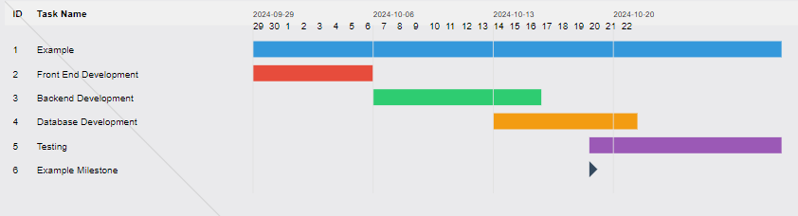

**Additional Planning Steps:**

* Continuous feedback from customers will be collected during each sprint to ensure iterative improvements.
* Additional improvements.